W1. |  | In a UML class diagram's representation of a class, the top, middle, and lower rectangular compartments respectively describe the _____ of the class.

(a) name, methods, and constants
(b) attributes, methods, and constants
(c) attributes, methods, and name
(d) name, attributes, and methods

 | Correct answer is | (d)

 | Feedback: | See section 1.2.1, subsection "Class Notation," in the course notes.

 | 2. |  | UML class diagrams can describe which of the following?  - The internal structure of classes  - Relationships between classes

(a) I only
(b) I and II
(c) None
(d) II only

 | Correct answer is | (b)

 | Feedback: | See section 1.2.1, subsection "Introduction," in the course notes.

 | 3. |  | A collection typically models a _____ relationship.

(a) zero-to-one
(b) one-to-one
(c) many-to-many
(d) one-to-many

 | Correct answer is | (d)

 | Feedback: | See section 1.2.3, subsection "Collections," in the course notes.

 | 4. |  | Consider the following UML class diagram.  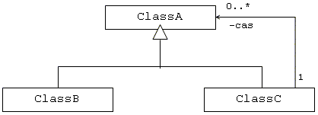  According to the diagram, which of the following statements is (are) true?  - ClassB is a specialization of ClassA.  - ClassA is a generalization of ClassC.  - ClassC is involved in a self-containment loop.

(a) I and II only
(b) I and III only
(c) II and III only
(d) I, II, and III

 | Correct answer is | (d)

 | Feedback: | Module 1.2

 | 5. |  | Which of the following is true about association and aggregation in UML class diagrams?

(a) Association is a special form of aggregation.
(b) Association and aggregation have no meaningful relationship.
(c) Aggregation is a special form of association.
(d) Association is the opposite of aggregation.

 | Correct answer is | (c)

 | Feedback: | See section 1.2.2 in the course notes.

 | 6. |  | A binary association is said to exist between two classes when

(a) an object of one class is instantiated in the same method as an object of the other class
(b) an object of one class requires an object of the other class
(c) one class belongs to the same package as the other class
(d) one class is a subtype of the other class

 | Correct answer is | (b)

 | Feedback: | See section 1.2.2, subsection "Associations," in the course notes.

 | 7. |  | Consider the following UML class diagram.  According to the diagram, instances of the class named _____ have references to instances of the class named _____.

(a) A, B
(b) B, C
(c) B, A
(d) A, C

 | Correct answer is | (a)

 | Your score on this question is: | 10.00

 | Feedback: | See section 1.2.2, subsection "One-way and Two-way associations," in the course notes.

 | 8. |  | If a class has an association with itself, then the class contains

(a) its own superclass
(b) an attribute that references an object of the same class
(c) a method that calls another method within the same class
(d) a method that calls itself

 | Correct answer is | (b)

 | Your score on this question is: | 10.00

 | Feedback: | See section 1.2.3, subsection "Self-containing Classes," in the course notes.

 | 9. |  | In an object model, the data that an object is responsible for maintaining are represented by

(a) generalizations
(b) methods
(c) attributes
(d) specializations

 | Correct answer is | (c)

 | Feedback: | See section 1.2.5, subsection "Identifying attributes," in the course notes.

 | 10. |  | When using noun-phrase analysis to model a software system, which of the following should typically be eliminated from the list of potential classes?  - References to the software system itself  - Nouns that imply roles between objects  - Synonyms to other nouns in the list

(a) III only
(b) I and III only
(c) I, II, and III
(d) II and III only

 | Correct answer is | (c)

 | Feedback: |  |  | See Chapter 10, page 216-219, in the course textbook.
3. |  |  | A relationship that exists between two specific instances of an object is known as a(n)

(a) link
(b) aggregation
(c) association
(d) specialization

 | Correct answer is | (a)

 | Feedback: |  |  | See Chapter 5, page 114, in the course textbook.
8. |  |  | Consider the following UML class diagram.  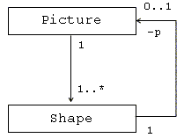  Which of the following is (are) true about the system described by the diagram?  - An instance of Picture can contain a collection of instances of the class Shape.  - An instance of Shape can contain a collection of instances of the class Picture.

(a) II only
(b) I only
(c) I and II
(d) None

 | Correct answer is | (b)

 | Feedback: | See section 1.2.3, subsection "Relationship loops1.2.3#Collections1.2.2#Multiplicity," in the course notes.

 | 9. |  | The static model of a software system typically includes which of the following?  - Attributes of classes  - Actions that occur between classes  - Structural relationships between classes

(a) I and II only
(b) II and III only
(c) I, II, and III
(d) I and III only

 | Correct answer is | (d)

 | Feedback: | See Chapter 10, page 213, in the course textbook.
View Assessment Result

 | 4. |  | Consider the following UML class diagram.  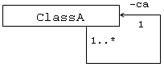The diagram describes a

(a) self-containing class
(b) one-to-one relationship
(c) class without methods
(d) relationship between a subclass and a superclass

 | Correct answer is | (a)

 | Feedback: | See section 1.2.3, subsection "Self-containing Classes," in the course notes.

 | 5. |  | The multiplicity of an association between two classes indicates the number of

(a) instances of one class that can be associated with an instance of the other class
(b) methods and variables common to both classes
(c) methods of one class that are called by the other class
(d) times that one class's methods are called by the other class

 | Correct answer is | (a)

 | Feedback: | See section 1.2.2, subsection "Multiplicity," in the course notes.

 | 8. |  | Consider the class described by the following diagram:  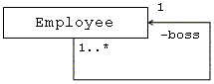  If the class represents an employee and the boss attribute refers to the employee's boss, which of the following statements is (are) true?  - Many employees can have the same boss.  - One employee can have many bosses.

(a) II only
(b) I only
(c) I and II
(d) None

 | Correct answer is | (b)

 | Feedback: | See section 1.2.3, subsection "Self-containing Classes," in the course notes.

 | 10. |  | An object model describes which of the following?  - Attributes of classes  - Methods of classes  - Relationships between classes

(a) I, II, and III
(b) I and II only
(c) II and III only
(d) I and III only

 | Correct answer is | (a)

 | Feedback: | See section 1.2.5, subsection "Process of Modeling Classes," in the course notes.

 | 6. |  | Consider the following UML class diagram.  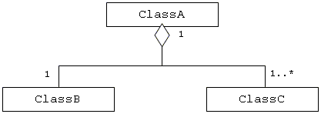  According to the diagram, which of the following statements is true?

(a) ClassA and ClassB each contain at least one reference to an instance of ClassC.
(b) ClassB and ClassC are both subclasses of ClassA.
(c) ClassA is composed of one instance of ClassB and one or more instances of ClassC.
(d) ClassB has a one-to-one association with ClassA and a one-to-many association with ClassC.

 | Correct answer is | (c)

 | Feedback: | See section 1.2.2, subsection "Aggregation," in the course notes.

